SCOG Community Orchard Management Plan

Drafted 20/12/23
To be reviewed each December

Health and Safety
Any volunteer group activity has a risk assessment. A qualified First Aider is also always present with an inspected first aid kit. The nearest defibrillator and location for emergency is on the back of the outdoor noticeboard and on the noticeboard of the container. The insurance policy does not cover mechanical or electrical machines. Any use of mechanical machines such as mowers or chainsaws is at the risk and liability of the owner. The insurance policy is on the noticeboard in the container.

Current management and managers
Nigel Baylem, as locals, keep an eye on the site.
Andy Cole mows the grassland using his own machines.
Graham looks after the container and its contents.
Paul Bennett helps Andy with some tasks.
Annie Hall involves local schools and scout groups in orchard projects like the bee hotel.
The website has the list of sponsored orchard trees. Most trees are now sponsored.
Adam, Jane, Mark and others scythe the grass.

Orchard trees
The plan for the trees is here on the SCOG website - https://www.scog.org.uk/scog-orchard
Some trees have been given small memorials by the sponsors.
Some poor growth or leaning trees have been removed to create open spaces for safe events or a fire pit area.
- Check missing red labels and renew where illegible. SCOG to consider etched aluminium labels.
- Remove aluminium numbered disks on tree trunks if able to remove without damage to trunk.
- Summer prune in late July to remove clustered fruit and diseased, damaged, crossing branches.
- Winter prune in late February. Prune to goblet or pyramidal shape with max. 25% removed per year. Remover lower branches to enable mowing. Put prunings in a pile to burn in November.
- Consider replacing some trees to add continuity and diversity eg. different species, rootstocks.
- Prune and tie espaliers and cordons regularly from June-Oct.

Grassland
This is mown every 2 – 4 weeks in strips from March to September by Andy using his own mower and fuel. SCOG cover his costs for fuel. SCOG to consider purchasing a mower.
The long grass areas have several introduced flowering plants such as Yellow Rattle.
- Mow strips and path by mowing machine every 2-4 weeks from March to September.
- Mow all by mowing machine in March/April to 10cm.
- Mow by scythe in August and finally mow again by machine in late Sept.
- Compost mowings at the base of the surrounding hedges.
- Remove anthills and lower tree branches as difficult to mow.

Hedges
Andy has used his own battery-powered hedgecutter, after the bird nesting season. He used a ladder with the help of other volunteers. Graham also has a battery-powered hedge cutter.
- Cut hedges once a year in Nov – Feb. Path hedge is cut at top each year and sides in alternate years with a wide base. Far side hedge is cut top and side each year.
- Trees in the hedge are periodically pollarded.
- Fill any gaps with new hawthorn.
- Allow space for passing items through hedge to container as an easy short cut.
- Cut snowberry growing behind the line of cordon trees.

Boundary fence
- Inform SKDC about need for maintenance.

Gate
The combination for the gate lock is 2003.
- Every two years treat with wood preservative.
- Repair gate with new treated wood.

Overhanging trees
- Cut overhanging branches with a long handled pruning saw.
- Thin or pollard hawthorn and ash trees.

Extra features
- Clean and re-construct Bee Hotel.
- Consider adding benches, hedgehog pile, swift boxes or owl perch.

Container
- SCOG to consider decorating outside of container using local youth group/ school for graffiti.
- Graham as Key Keeper and responsible for asset register of contents.

Seasonal Tasks
Early January – Wassail
Late February – Winter pruning. Cut remaining hedges.
March to September – Mow the grass strips
Late April/ Early May – Blossom time.
June – Midsummer party and inspection.
July – Summer pruning
August – Scythe long grass.
Late September – Harvest apples for Apple Day. Final machine mowing.
November – Cut hedges and overhanging tree branches. Burn prunings.

Additional Notes

Grass cuttings – to be added to a compost formed of wooden pallets. Alternatively organic mulch – to be added as a layer of bulky, organic material around the base of each tree in spring. This will suppress weed growth in the growing season, retain moisture in the soil for good root growth, build up soil life and feed the tree. Wood chip from deciduous trees could also be used.
Pruning – Dead and congested branches removed to create a goblet shape. Lower branches of apples – to be pruned to make mowing easier.
Tools – to be sharp and clean before using in the orchard to avoid the spread of fungal diseases. A pair of secateurs and a small pruning saw should be all that is needed for most jobs. Ladders and power tools – not to be used in the orchard by SCOG volunteers or the public unless by a qualified operator. SCOG's insurance does not cover the use of ladders or power tools.
Fence – to be supported upright with the elder tree behind the fence to be removed.
Fruit – to only be picked from the trees before Apple Day that can be used for demonstration, display and tasting at Apple Day. Local schools encouraged to pick fruit from the trees after Apple Day, with guidance from SCOG volunteers. The public encouraged to pick fruit from the ground.
Planting area – to be identified for planting one of the six famous local varieties on M25 rootstock to demonstrate the difference to MM106 rootstock trees, and to provide a longer lasting veteran tree.
Cow parsley – cut before seeding.
Native meadow plants – introduced successively, esp. Hay rattle to reduce grasses as a semi-parasite.
Bug hotel – introduced in 2017 and set up by a neighbouring primary school.
Harvesting – apples picked for Apple Day displays and tasting.
Tools and machines – SCOG has one scythe set. All other tools are owned and used by volunteers. Andy Cole provides a mower for grass-cutting.
Gate and posts – treated in 2019 with wood preservative.
Pesticides – No fungicides or herbicides have been used in the orchard.

Site Description
The orchard is at the end of Christchurch Close, off Green Lane, Stamford PE9 1HS. It was leased from South Kesteven District Council in 2006.

Aerial View - Google satellite Location - Ordnance survey Green space

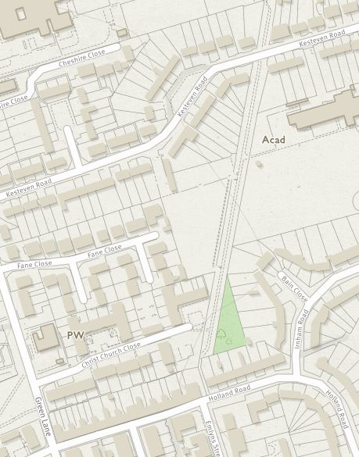
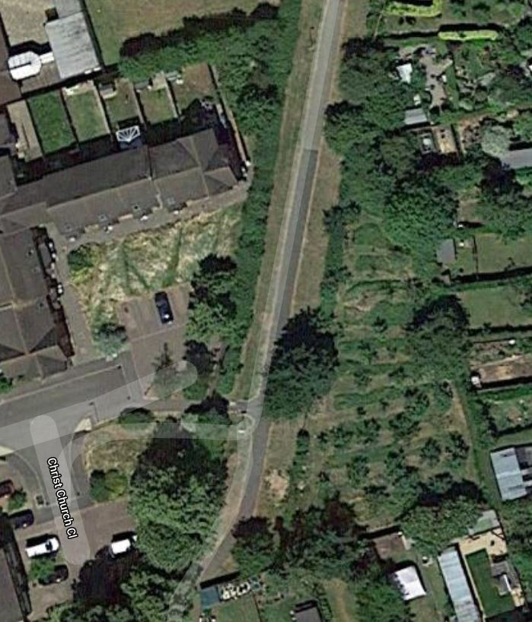

Objectives
- To conserve and demonstrate some local apple varieties, especially those raised by Browns Nursery of Stamford.
- To provide an easily accessible local green space for the local community, especially schools.
- To train volunteers and the public in the management and use of small orchards.
- To enrich and conserve the biodiversity of the orchard.

Ownership and lease
The site is leased from South Kesteven District Council. The rent is £100 for 5 years, renewable in 2024.

Description of trees and map
The site has 47 apple trees. They are all grown on MM106 rootstock. Six of the trees are grown as cordons at the southern end of the site. The plan for the trees is on the SCOG website - https://www.scog.org.uk/scog-orchard
Some trees have been given small memorials by the sponsors.
The 20 varieties include:

Allington Pippin
Barnack Beauty
Brown's Seedling
Lord Burghley
Peasgood Nonsuch
Schoolmaster
Cockett's Red
Dr Clifford
Ellison's Orange
Herring's Pippin
Holland Pippin
Ingall's Pippin
Ingall's Red
Isaac Newton
Laxton Pearmain
Lord Peckover
Peggy's Pride
Red Victoria
Sleeping Beauty
Uland

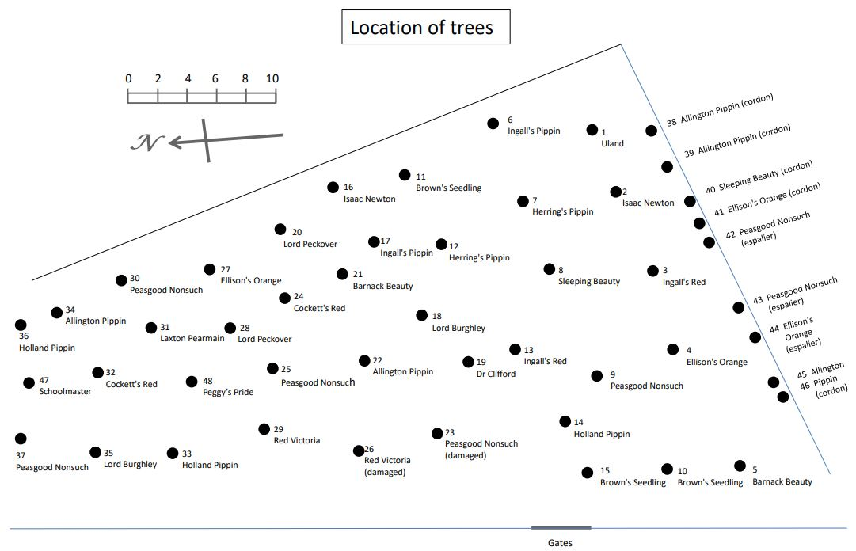
Accessibility
The orchard is open to the public. The main paths are safe and regularly checked. Dogs are welcome. Picnics are welcome, with visitors urged to dispose of any litter. Fires (including barbeques and fireworks) are not permitted. Car parking is at the end of Christchurch Close. There are no toilets or water on site.

Biodiversity
The apple trees attract pollinators in the spring such as honey bees, mason bees and bumblebees.
Introduced native flora – Hay rattle, Oxeye daisy, Snakeshead fritillary, Red and white campion, Black knapweed, Field scabious, Meadow cranesbill, Bloody cranesbill, Corncockle, cowslip, Field poppy etc. However not all of these have survived after being introduced.
Spanish bluebell and snowdrop, as non-native plants, have also been introduced. Daffodils were planted in 2020 below the hedge on the public path side.

Biodiversity will be encouraged with:
- A diversity of fruit varieties, flowering and fruiting at different times.
- A diversity of fruit tree ages and sizes, by successional planting.
- A diversity of mowing regimes to create a mosaic of grassland habitats with a gradual gradient from the hedge to the grassland.
- A diversity of introduced flowering plants to attract different pollinators.
- Some deadwood either in piles, on trees or as logs.

